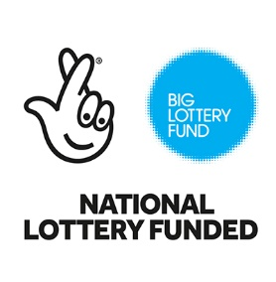

The Garadh’s Growing Spaces

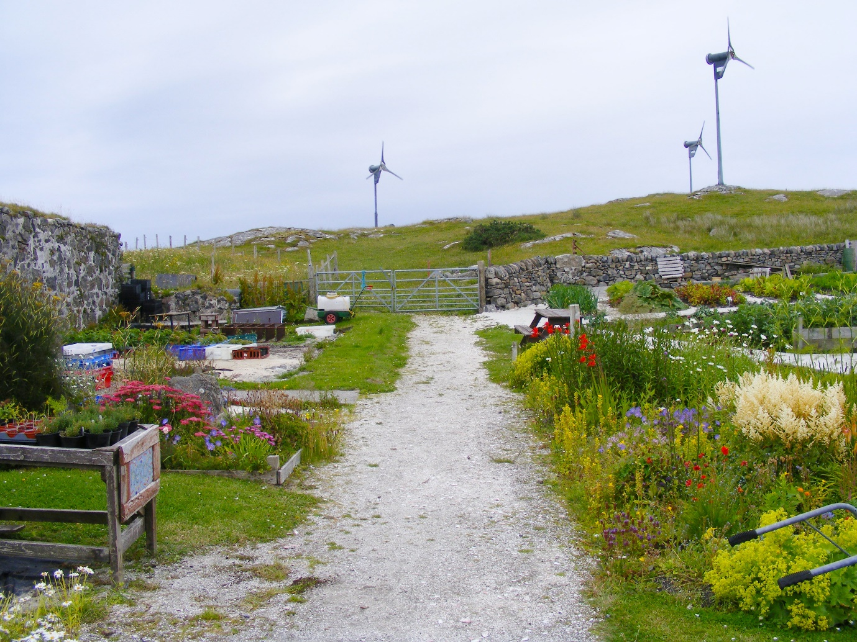

Garadh a Bhagh a Tuath wishes to give a huge **thank you** to the National Lottery players and Big Lottery Fund for their amazing grant of £830,000 towards our new purpose-built building.

This will provide a fantastic facility for all who use and visit the garden, including a service user led café and public toilet facilities.

CalMac, Scottish Government Transport and Hitrans have all contributed to including a state-of-the-art Changing Places toilet (the first in the Western Isles). This will meet the needs of our disabled visitors and volunteers at the site.

