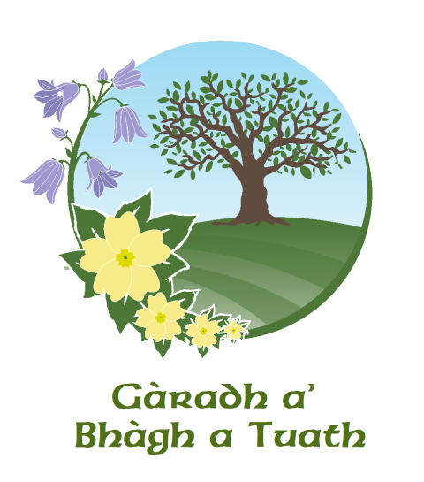
QUIZ NIGHT

Saturday 25th November

Castlebay Hall

Doors open at 8:30pm, starts 9:00pm

Bring your own bottle and snacks!
Admission £5.00 per person
Maximum of Six in a Team

Funds in aid of the Garadh new building

